Business Requirement Document

Project Name: ITSM Migration New App

Process Name: Problem Management Application

Version | Person in Charge | Date | Process Owner – KSGM
#1 | Phone Myat Soe & Khine Zar Thwe | 8 June 2023 | IT

Document Revision History

Date | Version | Revision Description | Author
8 June 2023 | 1.0 | New | Khine Zar Thwe
20 July 2023 | 1.1 | Add new state (Root Cause Analysis)  Update State Transition | Khine Zar Thwe

Table of Contents
Business Requirement Document 1
Project Name: ITSM Migration New App 1
Process Name: Problem Management Application 1
Document Revision History 1
Introduction 3
Process Description 3
Business Requirement 4
Requestor Details 4
Workflow 7
Business Steps 10
Business Rules 11
Button Visibility 11
Priority Matrix 12
Business Services & Technical Services 12
SLA Definition Data Matrix 12
SLA Definition 12
Email Notification 12

Introduction

Process Description

The primary goal of Problem Management is to prevent incidents from occurring, and if incidents do occur, prevent them from occurring again. Problem Management helps to identify the cause of an error in the IT infrastructure, reported as occurrences of related incidents. Resolving a problem means fixing the error that will stop these incidents from occurring in the future.

The “Problem” application is available to authorized users with appropriate role in backend environment only. Problem tickets can be created using Kissflow Problem application OR from an existing incident ticket OR even from a closed incident ticket. Problem Management process is structured in several states:

- Open: a new problem ticket, a root cause is being investigated, assigning a Problem ticket and Taking a Problem ticket
- Pending Change: A Problem ticket is waiting for an existing change request to be completed.
- Known Error: A Problem ticket has been investigated; the root cause has been identified.
- Closed/Resolved: A Problem ticket is being closed.

Business Requirement

Requestor Details

Field Name | Field Format | Mandatory | Formula/Validation
Number | Textbox | - | Auto Number populate
Business Service | Lookup | Yes | Editable – All related users
Technical Service | Lookup | Yes | Editable – All related users
Configuration Item | Lookup | - | Editable – All related users
Service Type | Dropdown | - | Editable – All related users  When business service is APIGW System (BS), Service type dropdown values are  - None  - Technical & Software Support Service -Onsite/Remote Support  - Helpdesk Service (LL)  When business service is Corporate Network Services, Service type dropdown values are  - None  - Telephone Support, Remote Assistant Service  - Technical & Software Support Service -Onsite and/or Remote Support  When business service is New Common Infrastructure (BS), Service type dropdown values are  - None  - Technical and Software Support Service Onsite  - Telephone Support, Remote Access Service  - Emergency Troubleshooting Service  - Hardware Support  - Helpdesk Service
Change Request | Lookup | Yes (Pending Change State) | Editable – All related users
Create Knowledge Article | Checkbox | - | Editable – All related users
Opened | Textbox | - | Auto Date & Time populate
Expected Delivery Time | Datetime | - | Auto Date & Time populate
PIC Contact | Lookup | Yes | Editable – All related users
State | Dropdown | - | Auto populate
Impact | Dropdown | Yes | Editable – All related users  Dropdown Values:  1-High  2- Medium  3- Low
Urgency | Dropdown | Yes | Editable – All related users  Dropdown Values:  1-High  2- Medium  3- Low
Priority | Text | Auto | Auto populate.  Dropdown Values:  1 - Critical  2 - High  3 - Moderate  4 - Low  5 - Planning
Assignment Group | Lookup | Yes | Editable – All related users
Assigned to | Lookup | - | Editable – All related users
Vendor Contact | Text | - | Editable – All related users
Date of Actual Production Release | Datetime | - | Editable – All related users
Vendor SLA Success | Checkbox | - | Editable – All related users
Vendor Contact (L3) | Lookup | - | Editable – All related users
Short Description | Text area | Yes | Editable – All related users
Description | Text area | Yes | Editable – All related users
Related Search | - | - | -
Notes | - | - | -
Work notes List | Lookup | - | Editable – All related users
Work notes | Text area | Yes | Editable – All related users
Problem | - | - | -
Root Cause Explanation | Text area | Yes (Known Error State) | Editable – All related users
Preventive Measures | Text area | - | Editable – All related users
Solution Details | Text area | - | Editable – All related users
Delivery | - | - | -
Actual Date for Quotation Information | Datetime | - | Editable – All related users
Actual Date for Implementation Completion | Datetime | - | Editable – All related users
Actual Date for Go-Live | Datetime | - | Editable – All related users
Requirement Settlement Date | Datetime | - | Editable – All related users
Estimated Date for Quotation Information | Datetime | - | Editable – All related users
Estimated Date for Implementation Completion | Datetime | - | Editable – All related users
Estimated Date for Go-Live | Datetime | - | Editable – All related users
Closure | - | - | -
Closed by | Lookup | - | Auto populate
Close notes | Text area | Yes (Close/Resolved State) | Editable – All related users
Closed | Datetime | - | Auto Date & Time populate

Workflow

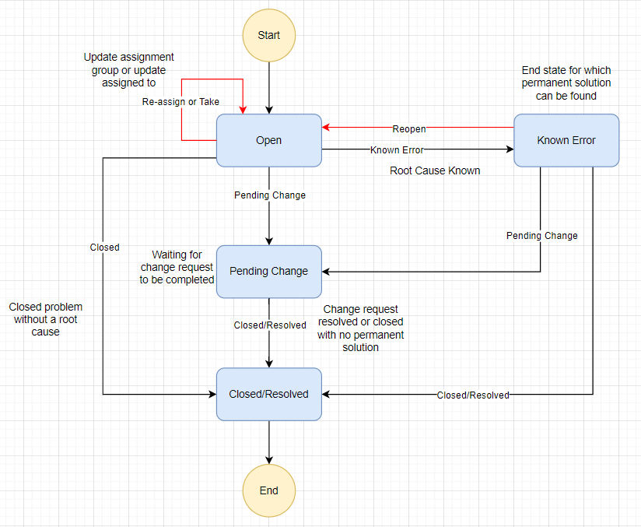
Figure 1 Problem Management Service Now State Diagram 1.0
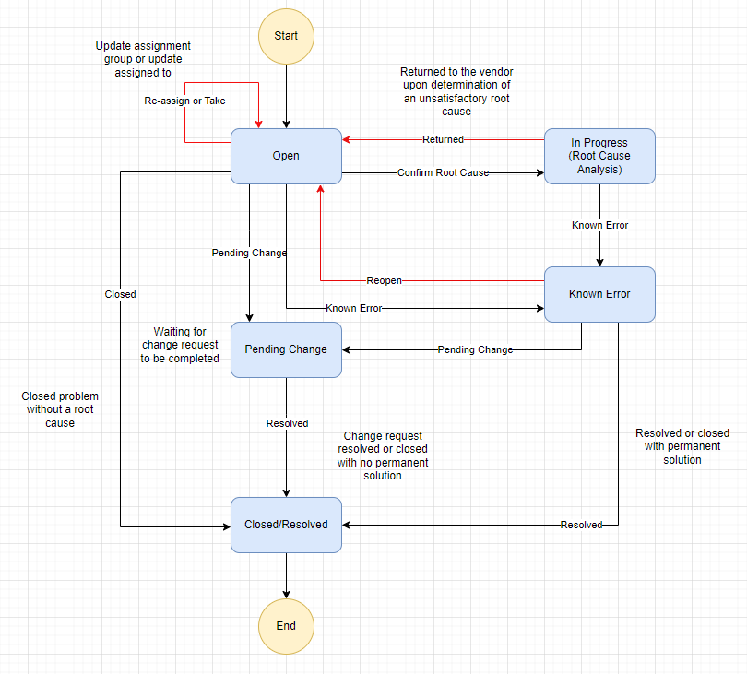
Figure 2 Problem Management State Diagram 1.1

MPT Problem Management: State Transitions Overview
State from | State to | Scenarios/ Comments
Open | Known Error | A problem ticket has been investigated and the root cause has been identified. Problem Ticket will be moved to the Known Error Database (KEDB).
Open | Root Cause Analysis (In progress) | The team investigates the problem, collects data, performs tests, and analyzes logs to identify potential root causes.
Open | Pending Change | A problem ticket will be linked to an open change request that might or does permanently solve the root cause of the problem.
Open | Closed/Resolved | The root cause of a problem cannot be identified, investigation was terminated, ticket will be closed.
Pending Change | Closed/Resolved | The change request lined to a problem ticket was completed, root cause was addressed, ticket will be closed.
Known Error | Open | A known error ticket will be reopened to resume the root cause analysis. Known error ticket will be removed from KEDB back to the list of open problem tickets.
Known Error | Pending Change | A problem ticket will be linked to an open change request that permanently solved the root cause of the problem.
Known Error | Closed/Resolved | A known error ticket is no longer relevant. There was no permanent solution completed or decided and the known error documented details, especially root cause and potentially the workaround, are no longer needed to be available in KEDB.
Root Cause Analysis (In progress) | Known Error | A problem ticket has been investigated and the root cause has been identified. Problem Ticket will be moved to the Known Error Database (KEDB).

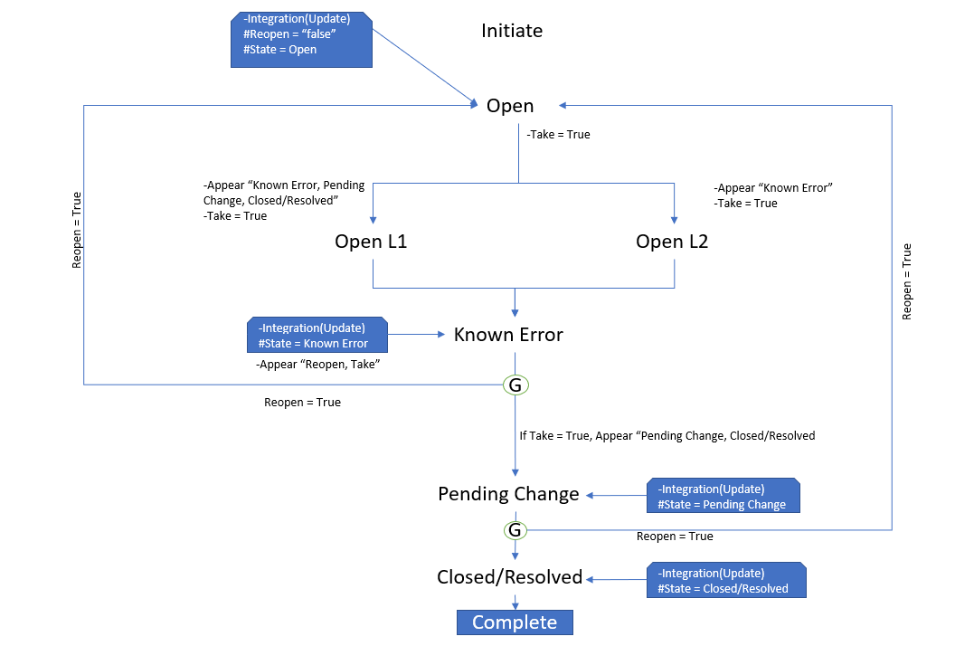
Figure 3 Workflow Diagram of Kissflow system

Business Steps

Step Name | Actor (Level) | Task Type | Condition/Rule | Permission
Open | Initiator | Create new Assign a ticket Take a ticket.  Reopen a ticket |  | Initiator  L1
Open L1 |  |  |  | L1
Open L2 |  |  |  | L2
Known Error |  | Investigate the problem Identified the root cause |  | L1
Pending Change |  | Waiting for an existing change request to be completed |  | L1
Closed/Resolved |  | Close a ticket |  | L1
Notification mail |  | Notification Mail |  | Read

Business Rules

Button Visibility

State |  | Login user | Submit | Take | Reopen | Close/ Resolved | Known Error | Pending Change
Open |  | Caller | Yes | No | No | No | No | No
Open | Before Take | Assignment Group L1 (Gatekeeper) | No | Yes | No | No | No | No
Open |  | Assignment Group L2 (Gatekeeper) | No | Yes | No | No | No | No
Open | After Take | Assignment Group (Gatekeeper) | No | Yes | No | No | No | No
Open |  | Assigned User L1 (MPT) | No | No | No | Yes | Yes | Yes
Open |  | Assigned User L2 (Vendor) | No | No | No | No | Yes | No
Known Error |  | Caller | No | No | No | No | No | No
Known Error |  | Vendor Contact | No | No | No | No | No | No
Known Error | Before Take | Assignment Group L1 (Gatekeeper) | No | Yes | Yes | No | No | No
Known Error | After Take | Assignment Group L1 (Gatekeeper) | No | Yes | Yes | No | No | No
Known Error | After Take | Assigned User L1 (MPT) | No | No | No | Yes | Yes | Yes
Closed/Resolved |  | Caller | No | No | No | No | No | No
Closed/Resolved |  | Assignment Group L1 (Gatekeeper) | No | No | No | No | No | No
Closed/Resolved |  | Assigned User L1 (MPT) | No | No | No | No | No | No
Pending Change |  | Caller | No | No | No | No | No | No
Pending Change | Before Take | Assignment Group L1 (Gatekeeper) | No | Yes | No | No | No | No
Pending Change | After Take | Assignment Group L1 (Gatekeeper) | No | Yes | No | No | No | No
Pending Change | After Take | Assigned User L1 (MPT) | No | No | No | Yes | No | No

Priority Matrix

